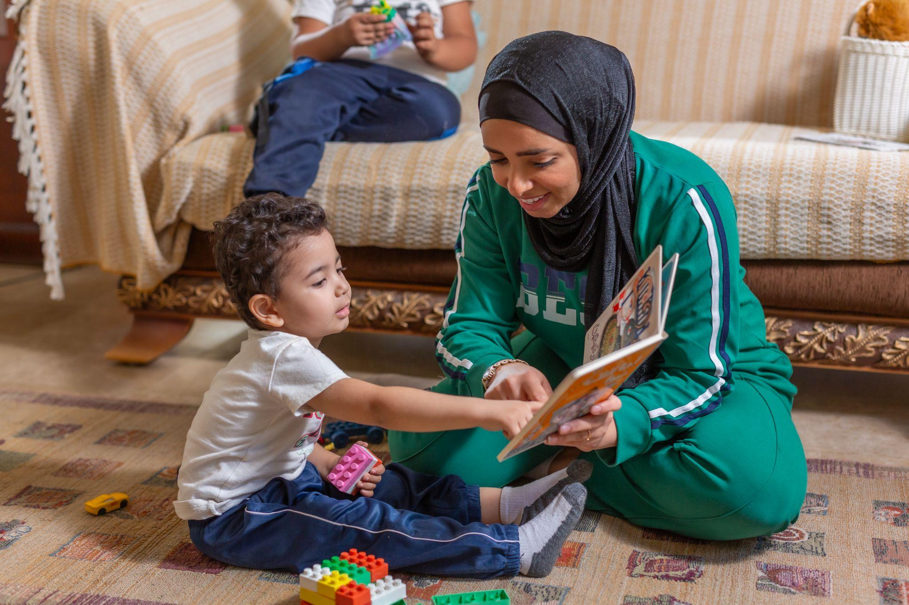

***impact evaluation for parental education program*** *- educator supported model*

**Executive Summary**

**July 2025**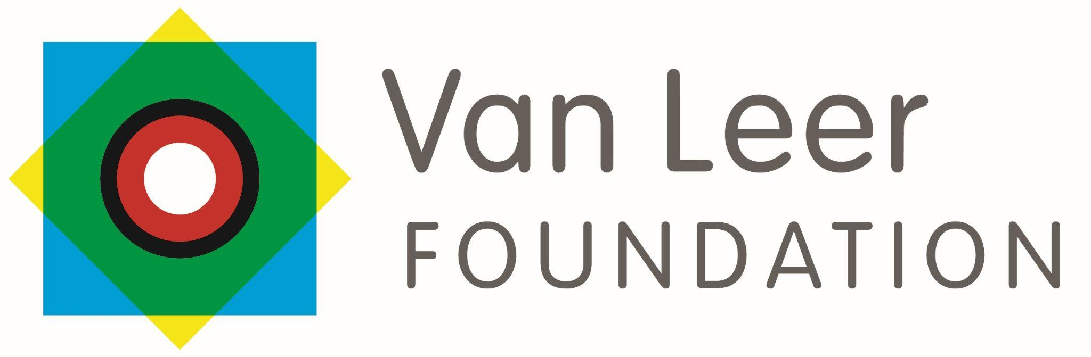

Abstract

The Queen Rania Foundation’s (QRF) Parental Education Program (PEP) aims to enhance caregivers’ capacity to support early childhood development through an 8-week WhatsApp-based course. In 2023–2024, the program expanded its reach via two delivery models: a self-led version and a ministry-aided model facilitated by Ministry of Islamic Affairs (MoIA) educators. This evaluation, focused on the MoIA-supported modality, used a mixed-methods design combining a Randomized Controlled Trial (RCT) and qualitative research.

Findings show that caregivers who received the program demonstrated statistically significant improvements in parenting engagement—particularly in reading, singing, and playing with their children. Educators valued the training and support systems, reporting increased confidence and skill in guiding parents. Despite promising results, challenges such as digital literacy gaps, and scalability constraints were identified. Recommendations emphasize the need for strengthened digital support, sustained parent follow-up, and improved recruitment diversity. PEP has shown measurable and meaningful impact, but sustained investment in infrastructure, capacity building and long-term engagement mechanisms will be essential for scaling and sustaining outcomes.

About the evaluators

This evaluation was completed by MMIS Management Consultants (MMIS) led by Maysa Abboushi and Tareq Albluwi and QRF’s Monitoring, Evaluation and Learning Team: Rawan Awwad and Sara Badran.

acknowledgments

We would like to thank all the parents, educators and MOIA staff participating in the study for their time and sincere answers about their experiences. We also appreciate the efforts of the educators responsible for delivering the ‘PEP’ intervention. We are also grateful to the core team at Queen Rania Foundation (Nour Awamleh and Dima Eimesayel) for supporting the evaluation, providing guidance and supplying recruitment information.

This research project has been funded by the Van Leer Foundation(VLF) and Theirworld.

# Executive Summary

1. Problem

Half of all 10-year-olds in Jordan cannot read and understand a simple text, as per World Bank and UNESCO indicators on "learning poverty."[1] Despite efforts to promote early childhood development, caregivers often lack accessible, contextualized, and sustained support on how to nurture these skills at home during the critical 0–5-year window

1. Intervention

The Queen Rania Foundation (QRF) launched the Parental Education Program (PEP) in 2017 to address this gap. Based on the Early Years Foundation Stage (EYFS) curriculum and supplemented with Vroom activities, PEP aims to build parental confidence and self-efficacy through an accessible 8-week digital course delivered via a WhatsApp based Chatbot.

In 2023 and 2024, the Parental Education Program (PEP) expanded its reach by reducing reliance on QRF staff and enhancing accessibility for caregivers through two delivery models. The first was a self-led model, allowing caregivers to independently complete the course through a WhatsApp-based chatbot. The second was a ministry-aided model, implemented in collaboration with the Ministry of Islamic Affairs (MoIA) and the Ministry of Social Development (MoSD) targeting only female caregivers. In this model, trained ministry educators facilitated closed WhatsApp support groups to complement the chatbot experience. These groups provided a space for additional guidance, where educators encouraged engagement, addressed caregivers’ questions, and led weekly discussions aligned with key child development topics—further supporting caregivers along their learning journey.

| In 2024, the program scaled further through several strategic actions:   * MoIA master educators were trained by QRF to cascade training and provide coaching to other ministry educators. * Ministry IT staff received training from QRF and its technical provider; eFlow, to manage the technical platform, enabling greater ministry ownership. * Partnerships expanded to include caregivers in orphanages and nurseries. * A blended training approach was introduced to educators, combining virtual sessions on the Edraak platform—which covered the foundational aspects of the program—with an in-person training of trainers designed to strengthen facilitation skills.   These efforts positioned PEP for wider implementation, sustainability, and long-term local engagement. |
| --- |

1. Evaluation

This evaluation adopted a mixed-methods approach, integrating a randomized controlled trial (RCT) with an Implementation Process Evaluation (IPE) informed by qualitative research. This evaluation covered only the MOIA-supported modality. Data collection took place in May 2024, and the final report was submitted in April 2025.

To assess the program’s impact on how caregivers engage with their children in everyday learning and development activities, the RCT randomly assigned 2,945 mothers, registered in the MOIA-supported modality, into treatment and control groups with the control registrants participating at a latter cycle in the same year, meas uring changes in engagement frequency across nine parenting activities (e.g., reading, singing, playing, and discussing emotions), through a caregivers’ survey. The survey was delivered at two-time points: upon registration (baseline) and one month after the end of the 8-week program cycle (endline).

The IPE explored implementation quality and user experiences through qualitative data collection, including Focus Group Discussions (FGDs) and Key Informant Interviews (KIIs) with the program implementers and parents. 10 FGDs were conducted with 58 parents from across Jordan’s north, center, and south, spanning both the 2023 and 2024 program cycles. Discussions were stratified by engagement level, separating high and low completers. In addition, 10 KIIs were conducted with program educators, including master educators, and two interviews were held with program focal points to gain insights into delivery practices and challenges.

1. Promising Findings

| * **Impact:** Caregivers who were offered the program showed a statistically significant increase in their engagement with their children. * Caregivers reported enhanced awareness, confidence, and patience in their parenting. * Educators were highly satisfied with the TOT and training provided, praising the comprehensive materials and the engaging and well-structured videos on Edraak platform. * Educators reported gaining practical skills in early childhood development, behavioral guidance, and parent engagement. |
| --- |

* **The impact evaluation (RCT) found that caregivers who were assigned to the program experienced a statistically significant increase in engagement with their children**. Caregivers in the treatment group reported an average increase of 0.42 points on a five-point scale—an 11% improvement compared to the control group. The program was especially effective in boosting activities like reading, singing, and playing.[2] Qualitatively, **Caregivers reported feeling more confident and engaged in their parenting. They appreciated the program’s flexibility, relatable content, and practical activities that fit easily into their daily routines.** Many highlighted improved emotional connections with their children and valued the encouragement and support from both facilitators and peers.
* **The recruitment strategy**—centered on Facebook advertisements and community-based referrals—**proved effective in reaching and enrolling a broad pool of caregivers into the program.**
* **Educators found the Edraak platform highly helpful in delivering the foundational training course and easy to use.** Educators appreciated the platform’s ease of use and its value as a reference tool for revisiting content.
* **The in-person Training of Trainers (ToT) effectively prepared educators for course delivery**. **Educators** **reported gaining practical skills in early childhood development, behavioral guidance, and parent engagement**. Moreover, they valued the structured, adaptable delivery of the program.
* **During project implementation, Educators reported positive, supportive relationships with master educators, who fostered confidence, independence, and a collaborative environment.** Master educators provided step-by-step assistance during initial challenges, addressed technical issues, and offered timely feedback through various communication channels, even outside standard hours.

1. Challenges

| **Recruitment challenges** | Although Facebook ads effectively reached many mothers, concerns regarding data privacy and distrust in social media platforms limited some caregivers’ willingness to register, resulting in unequal access and reduced recruitment diversity. |
| --- | --- |
| **High drop out rates** | A high number of participants dropped out of the program after completing one least one module (34%), or registered but did not start (52%); most left due to time constraints, lack of interest, or technical issues. However, this is still consistent with percentages expected in online courses. |
| **Low digital literacy and technical access** | A number of educators and caregivers struggled with using digital tools, which limited their ability to fully engage with the program and access its content. This highlights the need for stronger digital support systems and simplified technology use. |
| **Sustaining long-term impact** | While WhatsApp groups and the chatbot provided essential support—especially for ‘first-time’ mothers. 2023 participants requested continued follow-up through reminders, discussion groups, and educational materials. |
| **Scalability concerns** | As WhatsApp group sizes increased, it became harder for educators to manage discussions and provide timely support. This highlighted the need for better tech features, more manageable group sizes, and stronger digital skills among educators. |

1. Conclusions

The 2024 evaluation shows that PEP, especially in its MOIA-supported modality, positively affects parental behaviours that support early childhood development. It demonstrates both statistical and experiential impacts on parental engagement and self-efficacy. However, achieving scale will require investments in digital literacy, localized recruitment, and technical platform enhancements.

1. Recommendations

* **Sustain behavioral changes** by offering follow-up support to parents after program completion. This could include refresher workshops, post-program whatsapp based reminders for a longer period,discussion groups, and educational materials. This will contribute to addressing the challenge of sustaining the long-term impact.
* **Broaden recruitment efforts** by targeting underrepresented groups, including fathers and rural caregivers, through schools, health clinics, and trusted community figures.
* **Enhance the technical platform for educators** by redesigning it for ease of use, conducting usability testing, and integrating video tutorials. These improvements would help address digital literacy challenges and support scalability.
* **Expand feedback mechanisms** through regular in-person or live digital sessions that allow for direct input from participants.
* **Support educators digital literacy more effectively** through  **pre-course** training, mentorship from master educators, and refresher sessions on facilitation and tech use.

1. World Bank & UNESCO Institute for Statistics. (2022). *Jordan Learning Poverty Brief (June 2022)*. World Bank.<https://documents1.worldbank.org/curated/en/099125207202238514/pdf/IDU052d386470795a04627083760c02899ef1249.pdf>[documents1.worldbank.org+1documents1.worldbank.org+1](https://documents1.worldbank.org/curated/en/099125207202238514/pdf/IDU052d386470795a04627083760c02899ef1249.pdf?utm_source=chatgpt.com)
2. The Intent-to-Treat (ITT) analysis found that mothers assigned to the program reported a 0.35-point increase in engagement scores (p < 0.001), while those who actively participated (Treatment on the Treated analysis)[1] saw an even greater increase of 0.42 to 0.50 points, depending on their level of completion. The program’s strongest effects were observed in reading (β = 0.40, p < 0.001), singing (β = 0.47, p < 0.001), and playing (β = 0.36, p < 0.001) activities. reference: Glennerster, R., & Takavarasha, K. (2013). Running Randomized Evaluations: A Practical Guide. Princeton University Press.